ADVANCED POWER BUILDER TIPS

Use the M query to consolidate various workbooks with same columns into one

<https://www.myexcelonline.com/blog/consolidate-multiple-excel-workbooks-using-power-query/>

**= Excel.Workbook([Content])**

This will import the workbooks from within the Folder that you selected in Step 3

[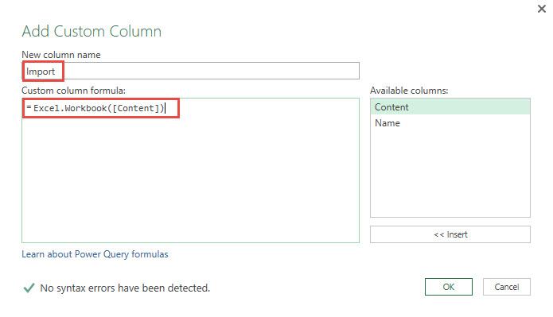](https://www.myexcelonline.com/wp-content/uploads/2016/05/add-custom-column2.jpg)